KM3Net-Fr installation site

Location and sharing basic facilities

The KM3NeT-Fr deep sea installation site is located about 45 km off-shore Toulon, France. Since the deep sea sites of KM3NeT-Fr and ANTARES are close, these research infrastructures share the building for the shore-stations for operation. As one of the partners in the MEUST project, KM3NeT-Fr shares both the deep sea and the shore facilities with marine science research groups.

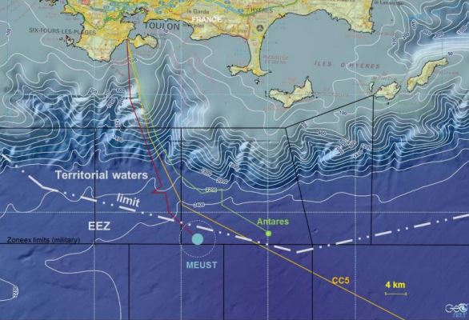
Map of the Mediterranean south of Toulon, France. The location of both the ANTARES and KM3NeT-FRs/MEUST site are visible.

At the seabed

At the seabed at a depth of about 2500 m, a high-speed electro-optical network is being prepared for transmission of the data from the deep sea to the shore, but also to send control commands from the shore station to the instrumentation and sensors in the deep sea.
The deep sea netwerk will consist of two sections, each with three nodes for connection of KM3NeT detection units and instrumentation for earth and sea sciences. The three nodes are interconnected and a main electro-optical cable (MEOC) runs to shore. The facilities of each node offer a junction box for connection of 5 series of 4 KM3NeT detection units, a KM3NeT instrumentation line for calibration purposes and a connector for instrumentation for earth and sea sciences research.

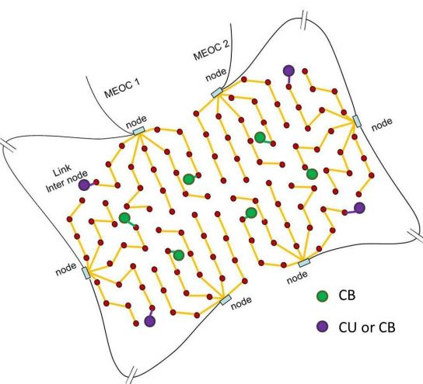
Schematic view of the KM3NeT-Fr ring-type seabed network of nodes.

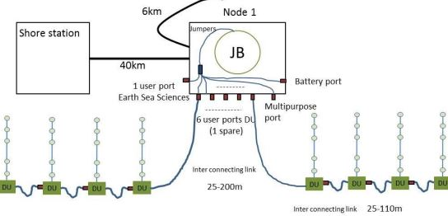
Schematic view of the connection of interlink cables between detection units and the junction box of a node in the KM3NeT-Fr seabed network.

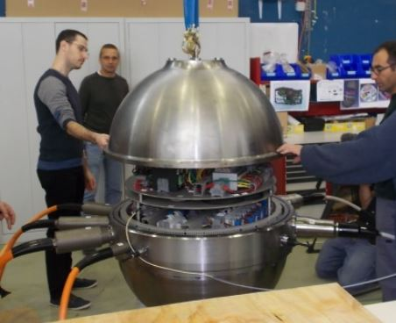
The junction box (JB) of the first node in the workshop of CPPM.

At the shore

At the shore, the main cables land in a power hut at the beach of Les Sablettes of La Seyne sur Mer. From there a land cable runs to a shore-station with high speed electronics and photonics and computers to receive the data from the deep sea, apply a first selection and reconstruction. The selected data are transmitted over the internet from the shore station to the KM3NeT data repository at the computing centre in Lyon.

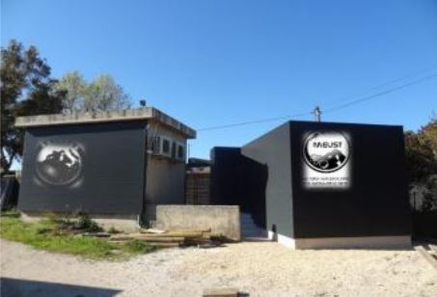
Power hut at the beach of Les Sablettes of La Seyne sur Mer, France, next to the one of ANTARES. Shared by the partners in the MEUST project.

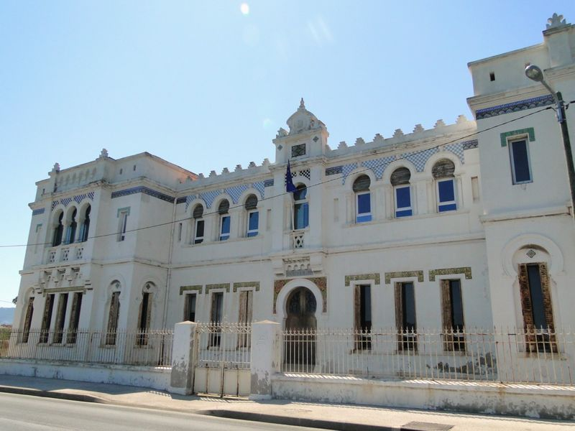
L'Institut de biologie marine Michel-Pacha: in this building the ANTARES shore station is located. The KM3NeT-Fr shore station will share the same location for the first years of operation.

First phase of implementation

The first phase of the KM3NeT-Fr seabed infrastructure will consist of one network node and a single main cable to shore.
In December 2014, the main electro-optical cable was succcessfully deployed byOrange Marine with its cable ship Descartes. The sea cable ends in a power hut at the beach of Les Sablettes of La Seyne sur Mer. From there, a land cable will run to the shore station where the installation of high speed data switches and a computer farm is being prepared. During KM3NeT-phase1, the first 700 m long detection unit will be connected to the KM3NeT-Fr infrastructure followed by the connection of six 100 m long compact detection units for the KM3NeT-ORCA detector.

<Foto meoc-on-ship>
MEOC at the deck of cable ship Descartes.

<Foto meoc-tray>
Digging a slit for the MEOC at the beach.

<Foto meoc-on-beach>
Laying the MEOC toward the powerhut at the beach.

In April 2015, the first node with a junction box was connected to the deep-sea end of the main cable using a deep-sea ROV. The node has sufficient sockets to connect in total 20 detection units, of which 7 will indeed be installed in the first phase of construction of KM3NeT. Connection of the first detection unit is expected in the early summer of 2015.

<Foto fr-node1-integration> (nella cartella della News 2)
The node in the lab of CPPM. Note the titanium vessel inside and the sockets at the upper bar.

<Foto fr-node1-boat> (nella cartella della News 2)
Loading the node on the Descartes.

<Foto fr-node1> (nella cartella della News 2)
Deployment of the node in the darkness of the early morning.

Next steps

The foreseen next step in the implementation of the KM3NeT-Fr infrastructure is to complete the seabed network to in total six nodes for connection of the 115 detection units of the low energy neutrino ORCA detector of KM3NeT.

